A000-ME-Assyria-Persepolis-Palace of Darius-Lion and Bull Ox-Sculpture for Nowruz-Limestone-500 BCE

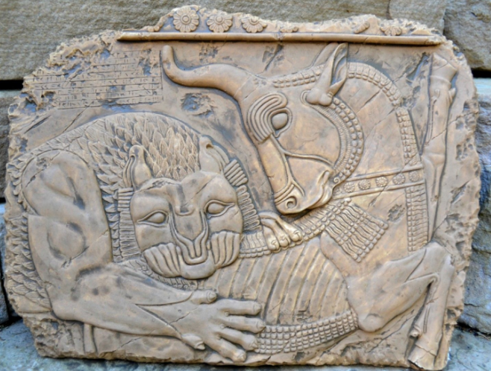

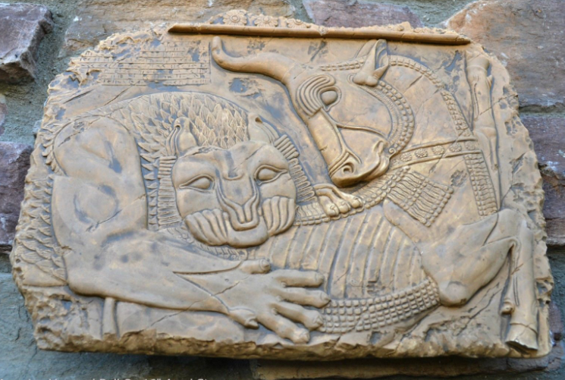

Figs. 1-2. ME-Assyria-Persepolis-Palace of Darius-Lion and Bull Ox-Sculpture for Nowruz-Limestone-500 BCE. From a plaster cast in the British Museum.

**Case no.: 3**

**Accession Number:**

**Formal Label:** ME-Assyria-Persepolis-Palace of Darius-Lion and Bull Ox-Sculpture for Nowruz-Limestone-500 BCE

**Display Description:**

Part of a bas relief of a lion attacking a bull in the audience hall (Apadana) of the Palace of Darius at Persepolis, Iran, begun 515 BCE, referring to the Zoroastrian Nowruz, from a 19th c plaster cast in British Museum. Nowruz (Persian: نوروز‎ *Nowruz*, [[nouˈɾuːz]](https://en.wikipedia.org/wiki/Help:IPA/Persian); literally "new day") is the name of the Iranian New Year's Day, also known as the *Persian New Year* ([*"Culture of Iran: No-Rooz, The Iranian New Year at Present Times"*](http://www.iranchamber.com/culture/articles/norooz_iranian_new_year.php). www.iranchamber.com*.* )Nowruz is the day of the vernal equinox, and marks the beginning of spring in the Northern Hemisphere. It marks the first day of the first month (Farvardin) of the Iranian calendar ([*"What Is Norooz? Greetings, History And Traditions To Celebrate The Persian New Year"*](http://www.ibtimes.com/what-norooz-greetings-history-traditions-celebrate-persian-new-year-1562607). International Business Times*. Retrieved 1 February 2016*.). It usually occurs on March 21 or the previous or following day, depending on where it is observed, at the moment when the Sun crosses the celestial equator and equalizes night and day. It is calculated exactly every year, and families gather together to observe the rituals.

There exist various foundation myths for Nowruz in Iranian mythology.

The Shahnameh dates Nowruz as far back to the reign of Jamshid, who in Zoroastrian texts saved mankind from a killer winter that was destined to kill every living creature (Moazami, M., 2002. The Legend of the flood in Zoroastrian Tradition. *Persica*, *18*, pp.55-74.). Similar to the biblical account of the flood (*Genesis* 6.1-9. 18.), the Akkadian Epic of Atra-Ḫasīs, the Babylonian Epic of Gilgameš, and the Indian tale of Manu, the Legend of the Flood is told in Zoroastrian literature. In the Iranian legend, however, the affliction is a plague from the Evil Spirit, the killer winter.   
The most complete account of the story of Jam is given in the second chapter of the *Vidēvdād*, a part of the *Avesta*, the sacred book of the Zoroastrians. The general subject of *Vidēvdād* is the rules of religious purity but it also contains some mythical and legendary narratives of old Iranian traditions such as the myth of Jam (Av. *Yima*), king of the Golden Age.

Jamshid, the mythical Iranian king, perhaps symbolizes the transition of the Proto-Iranians from animal hunting to animal husbandry and a more settled life in human history. In the Shahnameh and Iranian mythology, he is credited with the foundation of Nowruz. The book reads that Jamshid constructed a throne studded with gems. He had demons raise him above the earth into the heavens; there he sat on his throne like the Sun shining in the sky. The world's creatures gathered in wonder about him and the scattered jewels around him, and called this day the *New Day* (*Now Ruz*). This was the first day of Farvardin, which is the first month of the Iranian calendar (Ferdowsi, A., 2016. *Shahnameh: The Persian book of kings*. Penguin)

The first day of the Iranian calendar falls on the March equinox, the first day of spring, around 21 March. At the time of the equinox, the Sun is observed to be directly over the equator, and the north and south poles of the Earth lie along the solar terminator. Sunlight is evenly divided between the north and south hemispheres.

In around the 11th century CE, major reforms of the Iranian calendars took place and whose principal purpose were to fix the beginning of the calendar year, i.e. Nowruz, at the vernal equinox. Accordingly, the definition of Nowruz given by the Iranian scientist [Tusi](https://en.wikipedia.org/wiki/Nasir_al-Din_al-Tusi" \o "Nasir al-Din al-Tusi) was the following: "the first day of the official New Year [Nowruz] was always the day on which the sun entered Aries before noon.” (Abdollahy, R., 1990. Calendars ii. Islamic period. *Encyclopaedia Iranica*, *4*).

Nowruz is the first day of Farvardin, the first month of the Iranian solar calendar.

In the *Fasli*/*Bastani* variant of the Zoroastrian calendar, Navroz is always the day of the vernal equinox (March 21).

**The Above is Mostly From Wikipedia, q.v.**

**LC Classification:**

**Date or Time Horizon:** 500 BCE

**Geographical Area:** Persepolis

**Map:**

**GPS coordinates:**

**Cultural Affiliation:** Zoroastrian myth, Achaemenid sculpture

**Medium:** Limestone

**Dimensions:**

**Weight:**

**Condition:**

**Provenance:** after the British Museum plaster cast

**Discussion:**

**References:**

Abdollahy, R., 1990. Calendars ii. Islamic period. *Encyclopaedia Iranica*, *4*).

Anon a. calendar ([*"What Is Norooz? Greetings, History And Traditions To Celebrate The Persian New Year"*](http://www.ibtimes.com/what-norooz-greetings-history-traditions-celebrate-persian-new-year-1562607). International Business Times*. Retrieved 1 February 2016*.).

Anon b. *Year* ([*"Culture of Iran: No-Rooz, The Iranian New Year at Present Times"*](http://www.iranchamber.com/culture/articles/norooz_iranian_new_year.php). www.iranchamber.com*.* )

Ferdowsi, A., 2016. *Shahnameh: The Persian book of kings*. Penguin.

Moazami, M., 2002. The Legend of the flood in Zoroastrian Tradition. *Persica*, *18*, pp.55-74.